**Python Programming Internship(Week2)**

**Task 1:**

Write a program to count word frequencies in a given text.

from collections import Counter

import re

def count_word_frequencies(text):

# Removes punctuations & whitespaces

text = re.sub(r'[^\w\s]', '', text)

#converts text into lowercase

text = text.lower()

# Split the text into words and count their frequencies

word_list = text.split()

word_frequencies = Counter(word_list)

return word_frequencies

if __name__ == "__main__":

input_text = input("Enter the text: ")

word_frequencies = count_word_frequencies(input_text)

# Print the word frequencies

for word, frequency in word_frequencies.items():

print(f"{word}: {frequency}")

**Output:**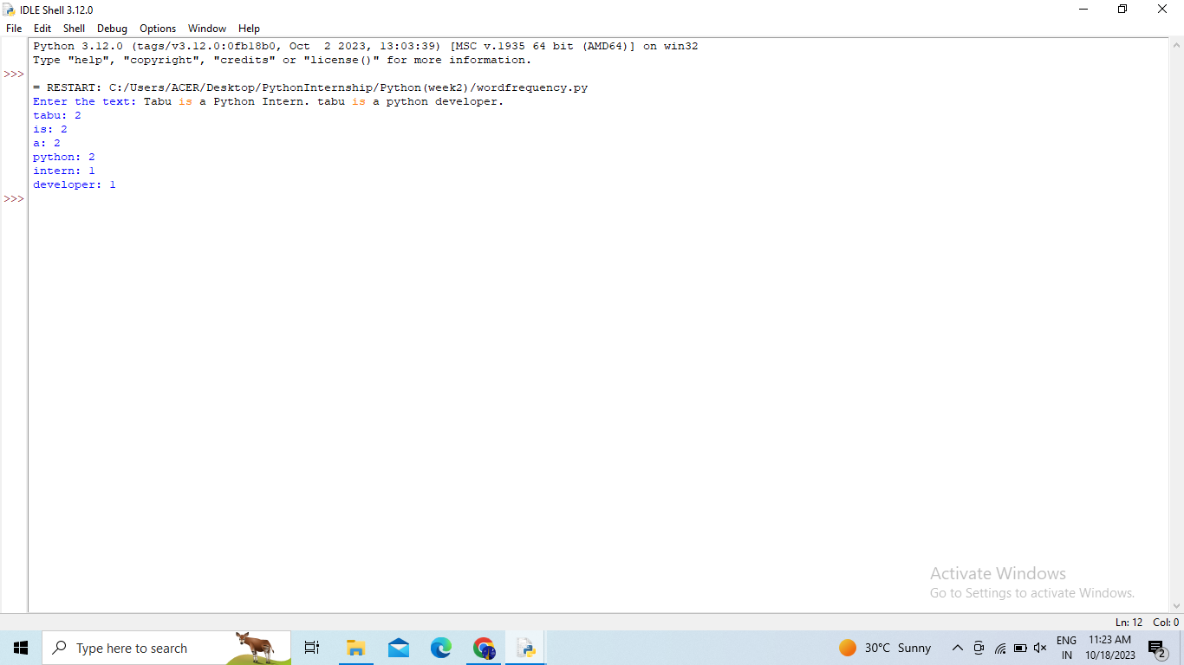

**Mini Project:**

Develop a basic to-do list program using functions and data structures add features like adding tasks in the to-do list, display the tasks and quitting the loop.

# Initialize an empty to-do list

todo_list = []

# Function to add a task to the to-do list

def add_task(task):

todo_list.append(task)

print(f"Task '{task}' added to the to-do list.")

# Function to display the tasks in the to-do list

def display_tasks():

if not todo_list:

print("Your to-do list is empty.")

else:

print("Tasks in your to-do list:")

for index, task in enumerate(todo_list, 1):

print(f"{index}. {task}")

#Function to remove the tasks in the to-do list

def remove_tasks(todo_list, task_index):

if 1 <= task_index <= len(todo_list):

removed_task = todo_list.pop(task_index - 1)

print(f"Task '{removed_task}' removed from the to-do list.")

else:

print("Invalid task index. Please enter a valid index.")

# Main program loop

while True:

print("\nOptions:")

print("1. Add a task")

print("2. Display tasks")

print("3. remove tasks")

print("4. Quit")

choice = input("Enter your choice: ")

if choice == "1":

task = input("Enter the task: ")

add_task(task)

elif choice == "2":

display_tasks()

elif choice == "3":

task_index = int(input("Enter the index of the task to remove: "))

remove_tasks(todo_list, task_index)

elif choice == "4":

print("Goodbye!")

break

else:

print("Invalid choice. Please choose a valid option (1, 2, or 3).")

# The program will keep running until you choose to quit (option 4).

**Output:**